Choosing a Just Right Book
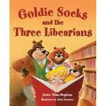
Author

Jacket
Useful
Spine
Title

Readability
Illustrations
General Appearance
Hook
Topic

Blurb
Opinion
Old Friend
Kind

